How to use IF function in Excel for Discounts

The IF function is a useful tool in discount calculations due to its ability to handle conditional discounts, provide flexibility, automate calculations, incorporate real-time updates, and enhance readability. It streamlines the discount application process, ensuring accurate calculations based on specific conditions.

The given dataset consists of eight products belonging to two categories: New Arrivals and Old. Each product is associated with a specific price, conditional discount (if applicable), and quantity ordered. The total cost of each order is calculated based on the price, discount, and quantity. In today’s tutorial we will learn how to use IF function for calculating discounts.

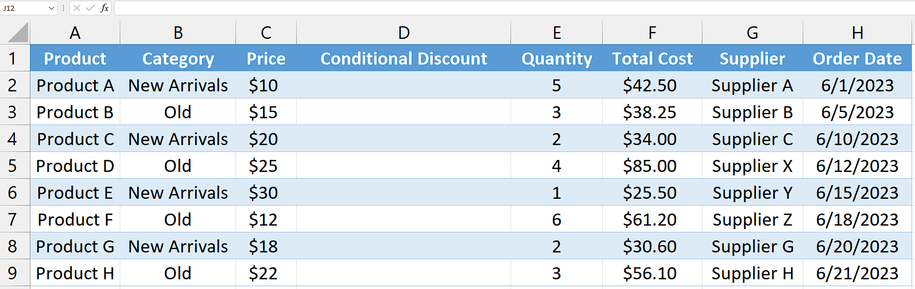

## Step 1 – Select the cell

* Select the cell where you would like to retrieve the "Conditional Discount" result.
* In this cell, we will apply the IF function to get our desired results.



## Step 2 – Write and implement the formula

* Write the following formula in the selected cell

=IF(B2<>"New Arrivals", C2*(1-0.1),"Discount Not Applicable")

Here is the breakdown of the formula:

**IF:** It is a logical function that allows you to perform different actions based on a specified condition.

**B2<> "New Arrivals":** This is the condition that checks if the value in cell B2 is not equal to "New Arrivals". If this condition is met, it means the product is not in the "New Arrivals" category.

**C2*(1-0.1):** If the condition is true (i.e., the product is not in the "New Arrivals" category), this part of the formula calculates the conditional discount. It multiplies the value in cell C2 (the price) by 1 minus 0.1 (10% discount), giving the discounted price.

**"Discount Not Applicable":** If the condition is false (i.e., the product is in the "New Arrivals" category), this part of the formula returns the text "Discount Not Applicable" indicating that no discount is applicable.

* Now, press Enter to get the result.



## Step 3 – Implement to the whole range

* To apply the formula across a range of cells, begin by selecting the cell containing the desired result, such as cell D2.
* Next, navigate to the bottom right corner of the cell until your cursor transforms into a plus (+) shape, known as the fill handle.
* Double-Click on this fill handle and the formula would be applied to the whole range.



## Explanation of formula used in Step 2:

The formula " =IF(B2<>"New Arrivals", C2*(1-0.1),"Discount Not Applicable") " essentially checks if a product is not in the "New Arrivals" category. If true, it calculates the discounted price by applying a 10% discount. If false, it returns the text "Discount Not Applicable".